News article – Ask your GP

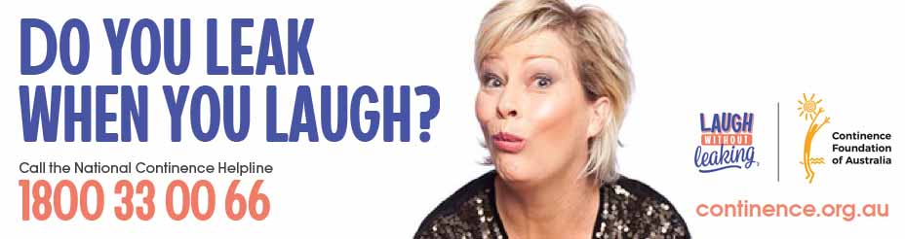

What can I ask my GP about incontinence?

Few people relish the thought of discussing their toilet habits with a GP. You should never feel embarrassed about discussing incontinence with a doctor. They are professionally-trained to relate to such matters.

Doctors are accustomed to dealing with issues of an intimate nature, including bladder and bowel problems. Do not let nerves stop you from taking the first step. The first time you discuss it is the hardest. But the more you talk about it, the easier it will become.

So how do you start the conversation?

The first step to improve your incontinence is to open the discussion with your doctor. Come to your appointment prepared with information about your bladder and bowel. Your doctor will not be in a position to help you unless you tell them what is happening to your body. You know your body, your routines, and you can identify changes in how you feel, better than anyone else. Your input is vital.

Before your appointment, it may help to think about and discuss with your GP:
- How often does the incontinence occur?
- Is it bladder or bowel incontinence?
- When did it start?
- What times of the day is the incontinence worse?
- Is there complete saturation, or just a small amount of urine or faeces?
- Do you have a fever? Or have you found it painful to go to the toilet?
- Is passing a bowel motion painful?
- What prescription and over-the-counter medication are you taking, if any?

Questions you may wish to ask your GP:
- What type or type/s of incontinence do you suspect I have?
- What type of bowel problem do I have?
- Might my incontinence be associated with heredity factors, lifestyle, medications, pregnancy, childbirth, menopause, or another medical condition?
- If my incontinence is related to an underlying medical condition, will treatment for this condition improve my symptoms?
- What types of diagnostic tests will help determine the type and severity of my incontinence?
- Should I keep a bladder and bowel diary?
- Without treatment, would you expect my symptoms to
- Gradually improve?
- Remain about the same?
- Continue to worsen?
- What steps (eg. diet and lifestyle changes) can I take to help manage my condition?
- How can I reduce my risk for rashes, odours, and other conditions associated with incontinence?
- Do you recommend pelvic floor muscle exercises? If so, how do I perform these exercises correctly?
- Why do you recommend this treatment?
- What can I expect before, during, and after treatment?
- If this treatment is unsuccessful, what other options are available?
- What are the potential side effects of incontinence medications? What should I do if I experience severe side effects?
- If my incontinence is related to menopause, might hormone replacement therapy (HRT) be helpful?
- If I continue to experience incontinence, what other options for treatment are available?

National Continence Helpline
Another option is to call the National Continence Helpline 1800 33 00 66.
You can speak to, or email your enquiry, to a qualified continence nurse adviser for confidential, expert advice. Ask them about continence products, and federal and state government subsidy schemes. They can also mail you printed information resources about incontinence. The Helpline can also provide you with information about your local continence service or clinic. It operates Monday to Friday 8am to 8pm (AEST).

Continence services and clinics
These are specialist services where you can obtain a full assessment of your bladder or bowel problems. These services usually have a continence nurse adviser or continence physiotherapist who can advise you on possible management options.
Ask the National Continence Helpline 1800 33 00 66 for the nearest service near you.

