News article – 5 healthy habits for

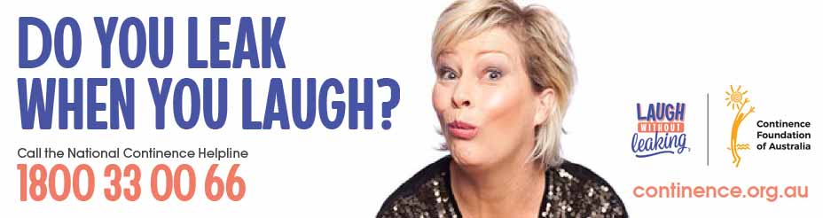

Five healthy habits for your bladder and bowel
Good healthy bladder and bowel habits can have a significant impact on our lives, and small changes in our daily habits can help prevent, or at least improve, urinary incontinence and faecal incontinence. By taking just a few of the following healthy steps in the right direction, you can make a positive impact on your bladder and bowel health.
- Drink well

While our tendency when dealing with bladder and bowel problems might be to restrict our liquid intake, this is actually the opposite of what we should do.
- Aim to drink an adequate amount of fluid a day, unless otherwise advised by your doctor
- Distribute your intake of drinks evenly throughout the day
- Drink more fluids (preferably water) if the weather is hot, or if you are exercising; and
- Cut down on alcohol, fizzy drinks and drinks with caffeine in them, as they irritate the bladder.
Tip: Don't reduce your fluid intake if you have a bladder control problem, as this will concentrate your urine and make the problem worse.
- Eat a healthy diet

You are what you eat, and eating well can make a world of difference to how we feel and how our bodies operate.
- Eat plenty of fibre, this improves bowel function by absorbing water and adding bulk to your bowel motions. Bulky stools keep things moving through your bowel to avoid constipation. Fibre is found in many foods including multigrain or whole grain breads, cereals and cereal products, fruit, vegetables, legumes, nuts and seeds
- Eat 2 servings of fruit, 5 servings of vegetables and 5 servings of cereals/(wholemeal) breads each day.
Tip: A high fibre diet means will require you to drink plenty of fluid as the fibre needs water to bulk up your bowel motions.
- Lead a positive lifestyle

Most of us have an unhealthy habit we say we will change - perhaps today is the day we take that first step?
- Maintain an ideal body weight with a Body Mass Index (BMI) of 25 or less. Excess body fat strains the pelvic floor and can lead to bladder and bowel control problems. Speak to your doctor or qualified dietitian for more information about how to safely lose weight; and
- Stop smoking. Chronic (long-term) coughing associated with smoking can weaken the muscles of your pelvic floor and lead to bladder and bowel control problems.
Tip: Talk to your doctor or pharmacist for information on quitting smoking and managing a chronic cough. You can also contact the Quitline on 131 848 to get information or advice about a smoking cessation plan.
- Get active

Making a move in the right direction, not matter how small, can make a big difference.
- Aim to exercise for 30 minutes most days. Exercise stimulates movement of the bowel, and even gentle exercise, like walking helps; and
- Do your pelvic floor muscle exercises regularly. Obesity, pregnancy, childbirth, regular heavy lifting and a chronic cough can all weaken the pelvic floor, but you can strengthen these muscles with specific exercises.
- Practice good toilet habits

Surprisingly, there are a few things you can do to make your visit to the toilet as effective as possible. Try these today.
- Go to the toilet when you get the urge to open your bowels, as this is the most effective time to completely empty them. Most people get the urge first thing in the morning or following a meal when eating has stimulated the bowel.
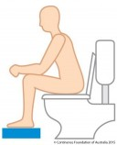
- Adopt the best posture for sitting on the toilet. When you sit on the toilet, place your elbows on your knees, lean forward and support your feet with a footstool. This helps to fully relax your pelvic floor and sphincter muscles. Bulge out your tummy, relax your back passage and let go (don’t hold your breath or strain). When you have finished firmly draw up your back passage.
- Avoid constipation, as this affects both bladder and bowel function. If you often strain to move your bowels, the pelvic floor stretches and weakens over time, impacting bladder control.
- Don't get into the habit of going to the toilet 'just in case'. Only go when you need to; and
- Visit your doctor as soon as you suspect a urinary tract infection.

Ask for help

Often we think we don’t have a bladder or bowel problems – we are just having a few ‘once off’ accidents. But this is how poor bladder and bowel health starts.

Seek help for bladder and bowel problems, as the symptoms will not go away on their own, and may worsen over time. For further information speak to your doctor or a continence nurse advisor on the free and confidential National Continence Helpline on 1800 33 00 66 or visit continence.org.au

